# Freezer Database

by isaac harris

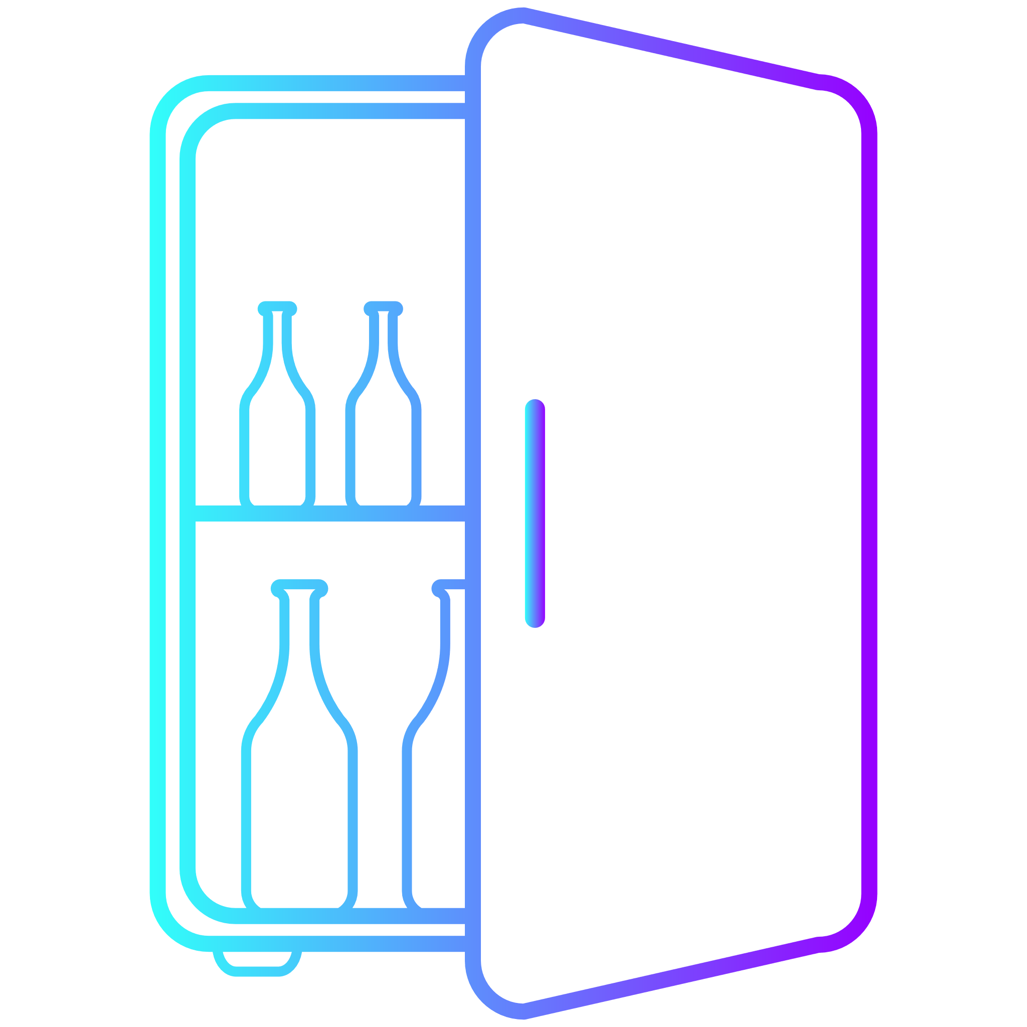

Written in C#  
using Microsoft Access

Initial Pitch

__________________________________________________________________________________

Freezer Database

my idea is a database interface which helps you manage your food inventory, it allows you to create “purchase” events which will add food products to your database, with relevant details such as the name, a short description/note (if desired) and the use by/best before date.

my database will remind you when food only has a day left, and will provide a dashboard to easily see what foods (and other produce) are close to going off, I will have a colour system where over 1 month is blue, over 1 week is green, over 3 days is yellow and any less is red (with black signifying food that has gone bad).

I will use a queue to show the recommended food items to use and alternatively a system which is sorted by use by date.

In the future I may decide to implement a system that allows you to scan produce to more easily add to the database, however this may be unfeasible to begin with.

I will create an option to add regularly used food items (allowing you to pick from a drop down menu, and also allowing you to get nutritional information more easily. you will still have to add the use by date when you create an instance (I will consider object oriented programming for this).

the project is designed for anybody who regularly buys perishable food and wishes to keep track of what they have to be more efficient in the use of food.

I am currently planning to use Access™ for my database and am going to be using C# Forms with SQL to present the data for easier consumption.

__________________________________________________________________________________

## Analysis

### Questionnaire